RAUM 31 (ROOM 31)
RAUM 31 Harald Holba

Compositing / 04:00 min. / BetaSP / © 2000 Harald Holba

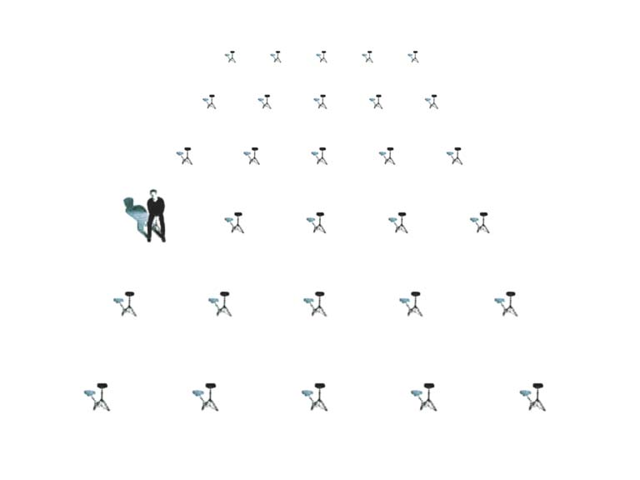
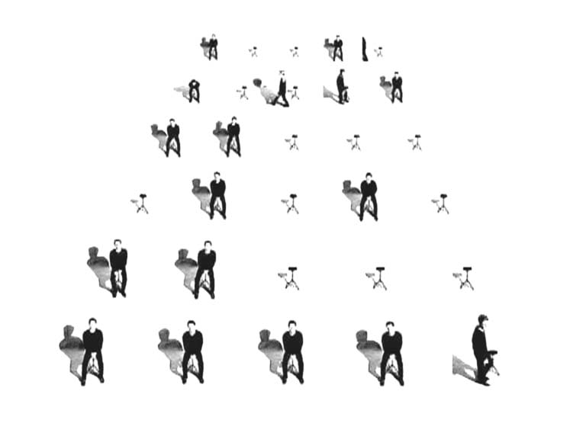

The story takes place in a room overshined by a bright white light. The furniture consists of 30 chairs aligned in precise order. The room is an experimentation platform for public, private and individual conceptions of space. The persons shown in this movie and the temporal discontinuity of their movements and noises represent the public area. Time-manipulations in the picture and in sound create displacements and distortions, which try to mark the blank room …
Harald Holba: *1977
Starts studying visual media at the university for applied arts in vienna in 1997. Completition of the course of visual media in summer 2004 with the degree of magister artium. Lives and works in vienna.

movie (selection):
BITCRUSHER / 11:20min, 2004
BUSTED 818 / 05:09min, 2002
POOL_2 / 04:57min, 2001
PLAN-C / 05:00min, 2001
RAUM 31 / 04:00min, 2000

http://www.holba02.at

