PL
PL Harald Holba

Computer animation / 01:00 min. / MiniDV / © 2002 Harald Holba


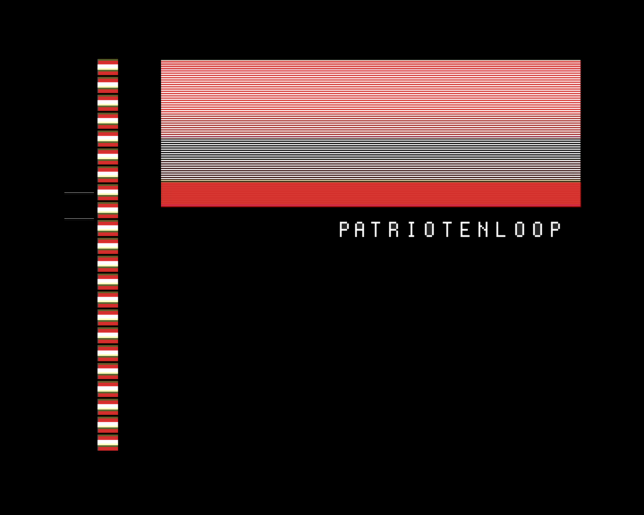

The minimalist content of the image comprises three elements: a colored vertical strip, colored horizontal field and a grey line. It gradually becomes obvious that the grey line is acting as an indicator and the horizontal field is an enlarged detail of the colored strip, which corresponds to the indicator`s position. The soundtrack also is clearly connected to the strip`s colors...
distribution / sixpackfilm
Harald Holba: *1977
Starts studying visual media at the university for applied arts in vienna in 1997. Completition of the course of visual media in summer 2004 with the degree of magister artium. Lives and works in vienna.

movie (selection):
BITCRUSHER / 11:20min, 2004
BUSTED 818 / 05:09min, 2002
POOL_2 / 04:57min, 2001
PLAN-C / 05:00min, 2001
RAUM 31 / 04:00min, 2000

http://www.holba02.at

