BUSTED 818
BUSTED 818 Harald Holba

3D computer animation / 05:09 min. / MiniDV / © 2002 Harald Holba

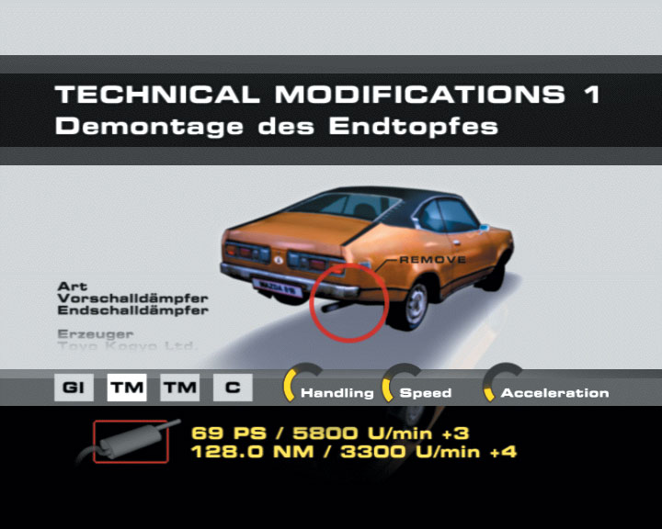
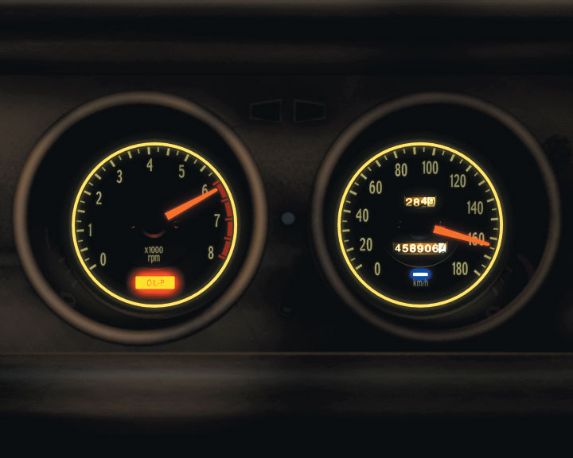

The first sequence of the video confronts the spectator with all details to the planned project. The deliberate destruction of a Mazda 818 by overspeeding the engine. In the following realtime sequence the visual information is reduced to a close-up showing the car instruments.
Through the exact composition of the visual elements and the emotionalizing sound recording the inevitable break down of the combustion engine turns into a dramatic experience.
distribution / sixpackfilm
Harald Holba: *1977
Starts studying visual media at the university for applied arts in vienna in 1997. Completition of the course of visual media in summer 2004 with the degree of magister artium. Lives and works in vienna.

movie (selection):
BITCRUSHER / 11:20min, 2004
BUSTED 818 / 05:09min, 2002
POOL_2 / 04:57min, 2001
PLAN-C / 05:00min, 2001
RAUM 31 / 04:00min, 2000

http://www.holba02.at

