BITCRUSHER
BITCRUSHER Harald Holba

computer animation / 11:10 min. / DVD BetaSP / © 2004 Harald Holba

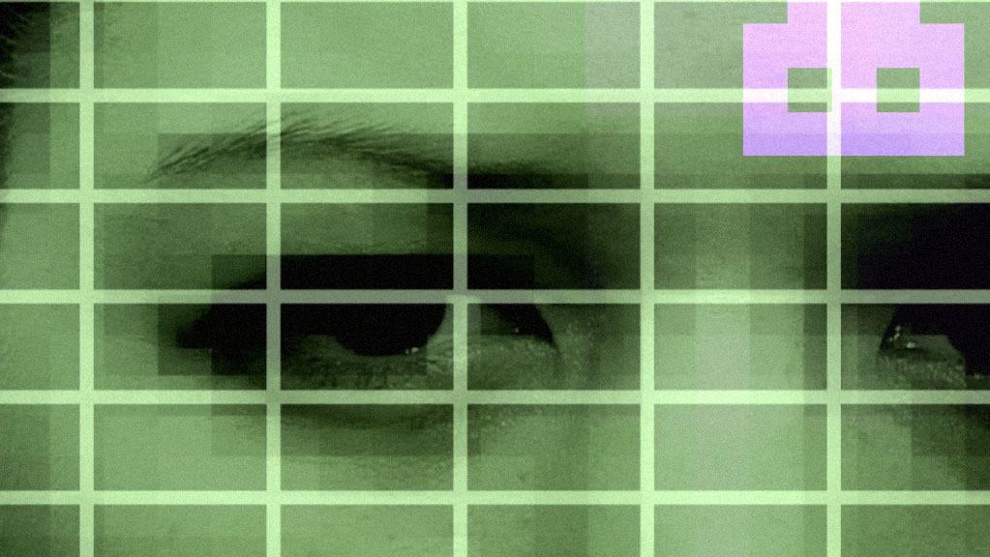
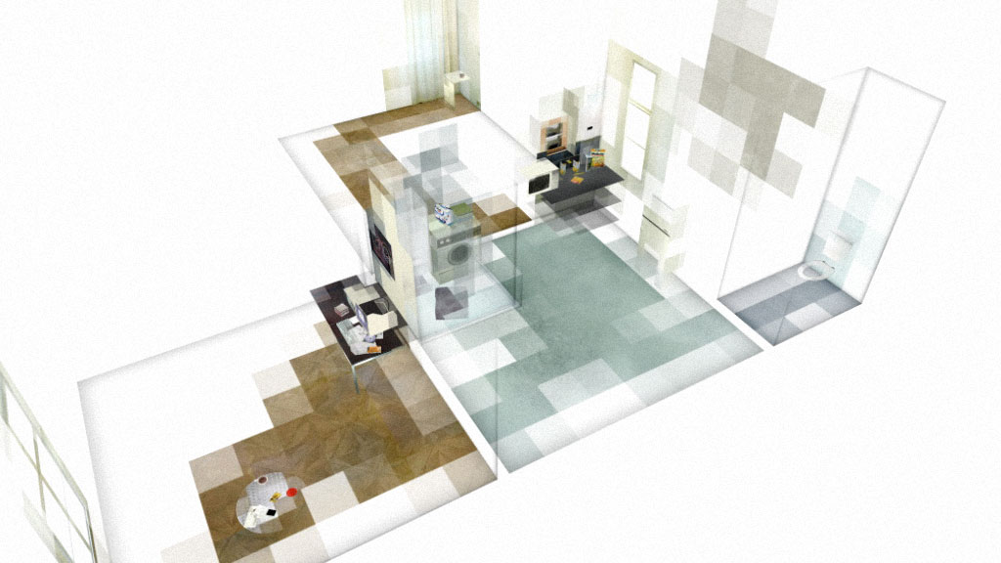

Black lines form a polygon on a white background. In one of the corners a line grows upward, creating a three-dimensional space. Small colored polygons with a variety of shading spread across this area until a floor, furniture, windows and walls become apparent. A fragmented apartment with a cup rotating in the microwave, but no humans.

The soundscape is inimalistic and resembles noises, emphasizing the impression that the spaces lead independent lives when space particles multiply and generate new environments. The fragmented path leads onto the street and into an office building in which computers running a video game occupy identical rooms. The reflection of a person’s face can be seen on a monitor in one of these offices, and the face melds with the game’s grid. The sense that the concretions of the space occur when someone moves inside it has now been confirmed.

The video sketches a map of forward movement, and it is filled in solely where people have left something resembling traces of memory in the architecture surrounding them. “Space is what stops the gaze, what the eyes run into” (Georges Perec: Species of Spaces). In Bitcrusher spaces are created by both the gaze and the movement within them. This interaction of human being and architecture blurs borders, interference begins to disrupt the surfaces, spaces meld into each other.
Harald Holba: *1977
Starts studying visual media at the university for applied arts in vienna in 1997. Completition of the course of visual media in summer 2004 with the degree of magister artium. Lives and works in vienna.

movie (selection):
BITCRUSHER / 11:10min, 2004
BUSTED 818 / 05:09min, 2002
POOL_2 / 04:57min, 2001
PLAN-C / 05:00min, 2001
RAUM 31 / 04:00min, 2000

http://www.holba02.at
The often-cited virtual space receives a new visual and tactile dimension.
(Andrea Pollach)

Translation: Steve Wilder
distribution / sixpackfilm

